A LIGHT WEIGHT SECURE AUDITING SCHEME FOR SHARED DATA IN CLOUD STORAGE
A “Project Stage II” Report submitted to JNTU Hyderabad in partial fulfilment of the requirements for the award of the degree

BACHELOR OF TECHNOLOGY
In

COMPUTER SCIENCE AND ENGINEERING(CYBER SECURITY)
Submitted by

MD.MIHA MUHATASHIMA 21S11A6224
K. ANKITHA 21S11A6206
T. SOWMYA 21S11A6254
K. ARTHI 21S11A6207
Under the Guidance of
DR. VAKA MURALI MOHAN
B. Tech., M. Tech., Ph. D
Principal & Professor


DEPARTMENT OF COMPUTER SCIENCE & ENGINEERING
(CYBER SECURITY)
MALLA REDDY INSTITUTE OF TECHNOLOGY AND SCIENCE
(Approved by AICTE New Delhi and Affiliated to JNTUH)
Accredited by NBA and NAAC with “A” Grade
Maisammguda, Medchal (M), Hyderabad-500100, Telangana
MAY 2025

DEPARTMENT OF COMPUTER SCIENCE & ENGINEERING
(CYBER SECURITY)
MALLA REDDY INSTITUTE OF TECHNOLOGY AND SCIENCE
(Approved by AICTE New Delhi and Affiliated to JNTUH)
Accredited by NBA and NAAC with “A” Grade
Maisammguda, Medchal (M), Hyderabad-500100, Telangana
MAY 2025



CERTIFICATE

This is to certify that the “Project Stage II” entitled “A LIGHT WEIGHT SECURE AUDITING SCHEME FOR SHARED DATA IN CLOUD STORAGE” has been submitted by MD. MIHA MUHATASHIMA (21S11A6224), K. ANKITHA (21S11A6206), T. SOWMYA (21S11A6254) and K. ARTHI (21S11A6207) in partial fulfilment of the requirements for the award of BACHELOR OF TECHNOLOGY in COMPUTER SCIENCE & ENGINEERING (CYBER SECURITY). This record of Bonafide work carried out by them under my guidance and supervision. The result embodied in this major project report has not been submitted to any other University or Institute for the award of any degree.

Dr. VAKA MURALI MOHAN Mrs. T. SAI KUMARI
Principal & professor HOD-CSE(CS)
Project Guide

External Examiner

ACKNOWLEDGEMENT
The Major Project work carried out by our team in the Department of Computer Science & Engineering (CYBER SECURITY), Malla Reddy Institute of Technology and Science, Hyderabad. This work is original and has not been submitted in part or full for any degree or diploma of any other university.
`We wish to acknowledge our sincere thanks to our project guide Dr. VAKA MURALI MOHAN, Assistant Professor, for formulation of the problem, analysis, guidance and her continuous supervision during the course of work.
We acknowledge our sincere thanks to Dr. Vaka Murali Mohan, Principal and Mrs. T. SAI KUMARI, Head of the Department and Coordinator, faculty members of Computer Science and Engineering (CYBER SECURITY) Department for their kind cooperation in making this Mini Project work a success.
We extend our gratitude to Sri. Ch. Malla Reddy, Founder Chairman MRGI and Sri. Ch. Mahender Reddy, Secretary MRGI, Dr. Ch. Bhadra Reddy, President MRGI, Sri. Ch. Shalini Reddy, Director MRGI, Sri. P. Praveen Reddy, Director MRGI, for their kind cooperation in providing the infrastructure for completion of our Mini Project.
We acknowledge our special thanks to the entire teaching faculty and non-teaching staff members of the Computer Science & Engineering (Cyber Security) Department for their support in making this project work a success.

MD. MIHA MUHATASHIMA 21S11A6224 _________
K. ANKITHA 21S11A6206 _________
T. SOWMYA 21S11A6254 _________
K. ARTHI 21S11A6207_________

INDEX
Chapter page no.
ABSTRACT vi
LIST OF FIGURES vii
1. SYSTEM ANALYSIS 1
1.1 Existing System 2
1.1.1 Disadvantages of Existing System 3
1.2 Proposed System 3
1.2.1 Advantages of Proposed System 3
1.3 Introduction 4
    - LITERATURE SURVEY 5
    - SYSTEM DESIGN 7
3.1 System Architecture 8
3.1.1 Modules 8
3.2 System Requirements 9
3.2.1 Hardware Requirements 9
3.2.2 Software Requirements 9
4. INPUT & OUTPUT DESIGN 11
4.1 Input Design 11
4.1.2 UML Diagrams 11
4.1.2.1 Use Case Diagram 12
4.1.2.2 Class Diagram 12
4.1.2.3 Sequence Diagram 13
4.1.2.4 Activity Diagram 14
4.2 Output Design 15
5. SOFTWARE ENVIRONMENT 16
5.1 Java Technology 17
5.1.1 History of java 18
5.1.2 What can java do 18
5.1.3 Why java 18
5.1.4 Java syntax compared to other programming 18
languages
5.1.5 Uses of Java 20
5.1.6 Java Features 20
5.2 JavaScript’s 21
5.2.1 JavaScript’s vs Java 22
5.3 Java Data base Connectivity (JDBC) 22
5.4 Java Server Pages (JSP) 23
5.4.1 Features of JSP 23
5.5 Tomcat 9.0 web server 24
6. SYSTEM STUDY 25
6.1 Economic Feasibility 26
6.2 Technical Feasibility 26
6.3 Operational Feasibility 26
7. SYSTEM TESTING 27
7.1 Types of Tests 28
7.1.1 Unit testing 28
7.1.2 Integration testing 28
7.1.3 Functional testing 29
7.1.4 System testing 29
7.1.5 Acceptance testing 30
7.2 Test Cases 30
8. RESULTS 33
9. CONCLUSION & FUTURE ENHANCEMENT 38
10. BIBLIOGRAPHY 40
11. YUKTI INNOVATION CERTIFICATE 42

ABSTRACT
A cloud platform provides users with shared data storage services. To ensure shared data integrity, it is necessary to validate the data effectively. An audit scheme that enables group members to modify data conducts the integrity verification of the shared data, but this approach results in complex calculations for the group members. The audit scheme of the designated agent implements a lightweight calculation for the group members, but it ignores the security risks between the group members and the agents. By introducing Hashgraph technology and designing a Third Party Medium (TPM) management strategy, a lightweight secure auditing scheme for shared data in cloud storage (LSSA) is proposed, which achieves security management of the groups and a lightweight calculation for the group members. Meanwhile, a virtual TPM pool is constructed by combining the TCP sliding window technology and interconnected functions to improve agent security. We evaluate our scheme in numerical analysis and in experiments, the results of which demonstrate that our scheme achieves lightweight computing for the group members and ensures the data verification process for security.

LIST OF FIGURES

FIG.NO | FIG NAME | PAGE NO
3.1 | System Architecture | 8
4.1.1.1 | Use Case Diagram | 12
4.1.1.2 | Class Diagram | 12
4.1.1.3 | Sequence Diagram | 13
4.1.1.4 | Activity Diagram | 14
4.1.1.5 | Component Diagram | 14
4.2 | Output Design | 15

LIST OF TABLES

Table Name | Page no
Software Requirements | 9
Hardware Requirements | 9
Test Cases | 32

CHAPTER – 1
SYSTEM ANALYSIS

1. SYSTEM ANALYSIS
1.1 EXISTING SYSTEM:
In a subsequent study, Ateniese et al. implemented a PDP scheme that supports dynamic operations, which means that the data uploader has full control over any operation performed on the cloud data, including block deletion, modification, and insertion. Then, Waters et al. proposed a full-dynamic PDP scheme by utilizing the authenticated flip table.
In 2016, Yang et al. proposed a BLS-based signature scheme supporting flexible management in the group. Jiang et al. proposed data integrity based on the vector commitment technique, which is resistant to collusion attacks of a cloud service provider and a group member. By combining proxy cryptography with the encryption technique, in 2017 Luo et al. proposed a scheme with secure user revocation. Recently, Huang et al. realized efficient key distribution within groups based on the logical hierarchy tree, thereby protecting the identity privacy of the group members. Huang et al. subsequently proposed a certificate less audit scheme by eliminating key escrow, which further improved the user's privacy security [13]. Following Huang et al.'s pioneering work. Fu et al. proposed an audit scheme that can restore the latest correct shared data blocks by changing the binary tree tracking data in the group.
Li et al. proposed a new cloud storage auditing scheme with a cloud audit server and a cloud storage server. The cloud audit server generates authentication labels for users before uploading them to the cloud storage server. Although this scheme can reduce users' computation overhead, it fully reveals the user's private key and the user's data to the cloud audit server. As a result, malicious cloud service providers can pass the verification process without storing the user's data. Guan et al. used an indistinguishable confusing approach to build an audit scheme for cloud storage, thereby reducing the time that is required to generate authentication labels but increasing the time to verify the integrity of the cloud data.

Wang et al. introduced agents to assist group members in generating authentication labels and auditing data integrity, which alleviated the computational burden for group members. However, in order to guarantee data privacy, the group member needs to encrypt the data before sending them to the proxy, which inevitably increases the computational burden. Shen et al. proposed a lightweight audit scheme by introducing the Third Party Medium (called the agent) to replace group members with generating authentication labels. Different from Wang et al.'s scheme, the scheme uses blind data instead of encrypted data to generate authentication labels Further reducing the computational burden on the group members.
1.1.1 DISADVANTAGES:
- No algorithm is used.
- It is static.
- Less communication and Fixed statement
- Less secure
- Less integrity and availability
1.2 PROPOSED SYSTEM:
The system is proposed by introducing an efficient blind method, this paper ensures the data privacy and identity privacy of the group members. By introducing a Hash graph, this paper avoids the hidden security risks of group members, and simultaneously makes the user identity traceable.
The TPM management strategy is designed, and the virtual TPM pool is built by the group manager. The strategy ensures the security of agent (TPM) and results in lightweight calculations for the agent. Using the TPM instead of group members to calculate the authentication label and audit data integrity results in lightweight calculations for the group members.
The security analysis of the scheme shows that the scheme is safe and can resist both replace attacks and replay attacks.
The experimental evaluation of the scheme shows that the scheme can achieve lightweight calculations for group members and the TPM.
1.2.1 ADVANTAGES:
- It provides effective communication.
- An CP ABE algorithm is used.
- It is Dynamic.
- It uses prepared statement.
- It is secure.
1.3 INTRODUCTION
Cloud computing is a new computing mode that was created after peer-to-peer computing, grid computing, utility computing and distributed computing. The core concept of cloud computing is resource renting, application hosting and service outsourcing [1]. Through virtualization technology, it forms distributed computing nodes into a shared virtualization pool in order to provide services for users. With cloud computing technology, users and enterprises do not need to spend much on the acquisition and maintenance of hardware in their early stages. In addition, powerful com putting and storage capabilities also make users more willing to rely on the cloud to handle a variety of complex tasks. When users choose to deploy a large number of applications and data to the cloud computing platform, the cloud computing system accordingly becomes the cloud storage system. Cloud storage systems give users mass storage capacity at a relatively low price, and provide a platform for sharing data between users (data sharing means that a user in a group uploads data to the cloud, and the rest of the group can access/modify the data).
However, highly centralized computing resources means cloud storage faces severe secu rity challenges. According to a survey conducted by Gartner in 2009, 70% of CEOs of surveyed companies refused to adopt cloud computing models on a large scale due to concerns about the privacy of cloud data. Furthermore, in recent years the security storage problem exposed by cloud operators has aroused people’s concern. For example, in March 2011, Google Gmail failed, which caused data loss to approximate 150,000 users. In the same year, Amazons enormous EC2 cloud service crashed, permanently destroying some user’s data. While the data loss was apparently small relative to the total amount of data stored, anyone who runs a website can immediately, understand the horrible level of data loss [3]. Thus, the secure storage of data in the cloud has hindered the large-scale use of cloud computing in the IT eld [4]. To achieve the secure storage of cloud data, researchers have developed the cloud data integrity verification scheme.

CHAPTER-2
LITERATURE SURVEY

2. LITERATURE SURVEY
A lightweight secure auditing scheme for shared data in cloud storage is essential for ensuring the integrity, privacy, and accountability of data, especially when multiple users interact with the same data in a cloud environment. Cloud storage services, while offering scalability and flexibility, present significant security challenges, particularly regarding data tampering, unauthorized access, and insufficient audit trails. Traditional methods of data integrity verification, such as full data verification or downloading files, are impractical due to high communication and computational costs. To address this, cryptographic techniques like Provable Data Possession (PDP) and Proof of Retrievability (PoR) have been widely adopted. These schemes allow users to verify data integrity without needing to access the full data, instead relying on lightweight cryptographic proofs. For instance, Merkle trees provide a way to efficiently check data integrity by representing large datasets with compact hash values, enabling quick and secure verification with minimal data transfer. Further, the integration of aggregate signatures (Li et al., 2014) enables the auditing of multiple data blocks with a single signature, significantly reducing verification overhead.
To improve the scalability and efficiency of auditing, third-party auditors (TPAs) have been introduced. These TPAs can verify the integrity of shared data on behalf of users without directly accessing the data, which not only reduces the burden on users but also ensures the transparency of cloud storage services. Public verifiability, as introduced by Wang et al. (2009), allows a TPA to periodically check data stored in the cloud and confirm its integrity, ensuring that data has not been tampered with. In dynamic cloud environments, where data is frequently modified (added, deleted, or updated), schemes like dynamic Merkle trees (Lu et al., 2015) have been developed to accommodate changes in data while maintaining efficient auditing. Blockchain technology has recently been proposed as an innovative approach to enhance the immutability and transparency of audit logs, allowing users and auditors to trust that auditing actions cannot be altered post facto.
Moreover, privacy concerns are addressed through schemes like homomorphic verifiable tags, which allow the verification of data integrity without exposing any actual data, thus ensuring user privacy while enabling audits. Machine learning-based anomaly detection has also been explored to identify irregular access patterns.

CHAPTER-3
SYSTEM DESIGN

3. SYSTEM DESIGN

3.1 SYSTEM ARCHITECTURE:
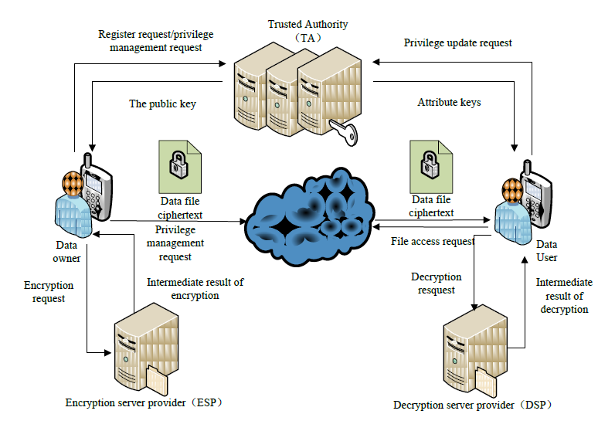
Fig 3.1: System Architecture

3.1.1 MODULES:
Data Owner
This module enables data owners to securely store and manage their encrypted data on a Cloud server. The data owner encrypts the data file before uploading it to the server, ensuring that even if unauthorized parties access the data, they will not be able to read or exploit it. The data owner can perform various operations, including viewing their profile, uploading files, viewing all uploaded files, and verifying the integrity of their data through block-level checks. This ensures that the data has not been tampered with or corrupted during storage or transmission. By providing a secure and efficient way to store and manage encrypted data, this module offers numerous benefits, including data security, integrity, and management.

Cloud Server
The Cloud server plays a crucial role in providing a secure data storage service for Data Owners. Data owners can encrypt their sensitive data files and store them on the Cloud server, which enables them to share the data with authorized Data Consumers. Through the Cloud server, Data Owners can perform various operations to manage their data and monitor its access. They can view their stored files, track download requests from Data Consumers, and monitor all transactions related to their data. Additionally, the Cloud server provides features to detect and alert Data Owners of potential security threats, allowing them to view any identified attackers. Furthermore, the Cloud server also provides insights into the time delay result, which helps Data Owners to evaluate the performance and efficiency of the data sharing process.
Group Member
In this module, a secure and controlled access mechanism is implemented, allowing members to access data files only with a secret key. This ensures that sensitive data is protected from unauthorized access. Once authenticated, members can utilize the search functionality to find specific files containing a specified keyword. The cloud server indexes the data matching the keyword, enabling efficient retrieval and response to the end-user. Members can also perform various operations, including viewing and managing their profile, searching for files, and requesting downloads, all subject to access controls and authorization to ensure secure data transfer.
TPM
In this module, the Trusted Third Party (TPM) plays a crucial role in managing and authorizing access to data. The TPM performs various operations, including viewing all data owners and authorizing their access, as well as viewing all end-users and authorizing their access to specific data files. Additionally, the TPM can view file details, enabling it to make informed decisions regarding access control and authorization, thereby ensuring the secure and controlled sharing of sensitive data.

3.2 SYSTEM REQUIREMENTS:
3.2.1 HARDWARE REQUIREMENTS:
Processor | Intel Core i5
RAM | 8GB
Hard Disk | 125GB

3.2.2 SOFTWARE REQUIREMENTS:
Operating system | Windows
Application server | Apache Tomcat 9.0
Front End | HTML, JSP
Scripts | JavaScript
Server Side Script | Java Server Pages
Database | My SQL 5.0
Database Connectivity | JDBC

CHAPTER-4
INPUT AND OUTPUT DESIGN

4.1 INPUT DESIGN
4.1.1 UML DIAGRAMS
UML stands for Unified Modelling Language. UML is a standardized general purpose modelling language in the field of object-oriented software engineering. The standard is managed, and was created by, the Object Management Group. The goal is for UML to become a common language for creating models of object-oriented computer software. In its current form UML is comprised of two major components: a Meta-model and a notation. In the future, some form of method or process may also be added to; or associated with, UML.
The Unified Modelling Language is a standard language for specifying, Visualization, Constructing and documenting the artifacts of software system, as well as for business modelling and other non-software systems. The UML represents a collection of best engineering practices that have proven successful in the modelling of large and complex systems. The UML is a very important part of developing objects-oriented software and the software development process.
GOALS:
The Primary goals in the design of the UML are as follows:
- Provide users a ready-to-use, expressive visual modelling Language so that they can develop and exchange meaningful models.
- Provide extendibility and specialization mechanisms to extend the core concepts.
- Be independent of particular programming languages and development process.

4.1.1.1 USE CASE DIAGRAM:
A Use Case Diagram is a graphical representation of the functional requirements of a system, showing the interactions between actors (users or external systems) and the system itself. It is a type of behavioral diagram in Unified Modeling Language (UML).

Fig 4.1.1.1: Use case Diagram

4.1.1.2 CLASS DIAGRAM:
A Class Diagram is a graphical representation of the static structure of a system, showing the relationships between classes, attributes, and operations. It is a type of static structure diagram in Unified Modeling Language (UML).

Fig 4.1.1.2: Class Diagram

4.1.1.3 SEQUENCE DIAGRAM:
A Sequence Diagram is a graphical representation of the dynamic behavior of a system, showing the sequence of interactions between objects or components over time. It is a type of interaction diagram in Unified Modeling Language (UML).

Fig 4.1.1.3: Sequence Diagram

4.1.1.4 Activity Diagram
An Activity Diagram is a graphical representation of the dynamic behavior of a system, showing the flow of activities, actions, and decisions involved in a business process or system function. It is a type of behavioral diagram in Unified Modeling Language (UML).

sucess

Fig 4.1.1.4: Activity diagram

4.2 Output Design
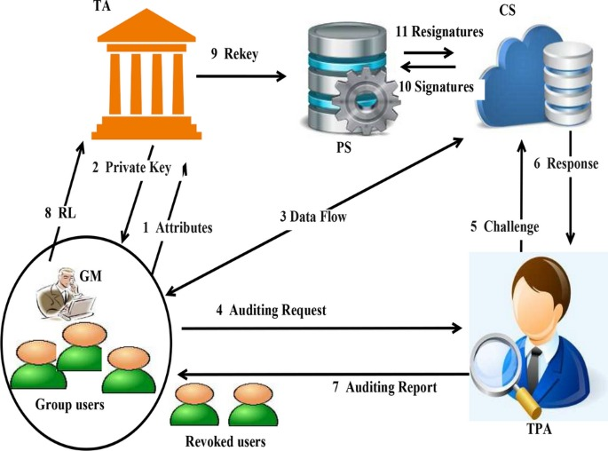

Fig 4.2: Output design

CHAPTER-5
SYSTEM ENVIRONMENT

5.SYSTEM ENVIRONMENT

5.1 Java Technology
Java is a programming language and computing platform first released by Sun Microsystems in 1995. It has evolved from humble beginnings to power a large share of today’s digital world, by providing the reliable platform upon which many services and applications are built. New, innovative products and digital services designed for the future continue to rely on Java, as well.
While most modern Java applications combine the Java runtime and application together, there are still many applications and even some websites that will not function unless you have a desktop Java installed. Java.com, this website, is intended for consumers who may still require Java for their desktop applications.
The Java Programming Language
The Java programming language is a high-level language that can be characterized by all of the following buzzwords:
- Simple  - Object oriented  - Distributed  - Multithreaded  - Dynamic | - Architecture neutral  - Portable  - High performance  - Robust  - Secure

Each of the preceding buzzwords is explained in The Java Language Environment , a white paper written by James Gosling and Henry McGilton.
In the Java programming language, all source code is first written in plain text files ending with the .java extension. Those source files are then compiled into .class files by the java c compiler. A .class file does not contain code that is native to your processor; it instead contains bytecodes — the machine language of the Java Virtual Machine¹ (Java VM). The java launcher tool then runs your application with an instance of the Java Virtual Machine.
Because the Java VM is available on many different operating systems, the same .class files are capable of running on Microsoft Windows, the Solaris™ Operating System (Solaris OS), Linux, or Mac OS. Some virtual machines, such as the Java SE HotSpot at a Glance, perform additional steps at runtime to give your application a performance boost. This includes various tasks such as finding performance bottlenecks and recompiling (to native code) frequently used sections of code. Through the Java VM, the same application is capable of running on multiple platforms.

5.1.1 History of Java
Initially the language was called as “oak” but it was renamed as “Java” in 1995. The primary motivation of this language was the need for a platform-independent (i.e., architecture neutral) language that could be used to create software to be embedded in various consumer electronic devices.
5.1.2. What can Java do?
Java has had a profound effect on the Internet. This is because; Java expands the Universe of objects that can move about freely in Cyberspace. In a network, two categories of objects are transmitted between the Server and the Personal computer. They are: Passive information and Dynamic active programs. The Dynamic, Self-executing programs cause serious problems in the areas of Security and probability. But Java addresses those concerns and by doing so, has opened the door to an exciting new form of program called the Applet.
5.1.3 Why Java?
Java can be used to create two types of programs:
Applications and Applets: An application is a program that runs on our Computer under the operating system of that computer. It is more or less like one creating using C or C++.
Java’s ability to create Applets makes it important. An Applet is an application designed to be transmitted over the Internet and executed by a Java –compatible web browser. An applet is actually a tiny Java program, dynamically downloaded across the network, just like an image. But the difference is, it is an intelligent program, not just a media file. It can react to the user input and dynamically change.
5.1.4 Java syntax compared to other languages:
The key that allows the Java to solve the security and portability problems is that the output of Java compiler is Byte code. Byte code is a highly optimized set of instructions designed to be executed by the Java run-time system, which is called the Java Virtual Machine (JVM). That is, in its standard form, the JVM is an interpreter for byte code.
Translating a Java program into byte code helps makes it much easier to run a program in a wide variety of environments. The reason is, once the run-time package exists for a given system, any Java program can run on it.

Java Virtual Machine (JVM):
Beyond the language, there is the Java virtual machine. The Java virtual machine is an important element of the Java technology. The virtual machine can be embedded within a web browser or an operating system. Once a piece of Java code is loaded onto a machine, it is verified. As part of the loading process, a class loader is invoked and does byte code verification makes sure that the code that’s has been generated by the compiler will not corrupt the machine that it’s loaded on. Byte code verification takes place at the end of the compilation process to make sure that is all accurate and correct. So byte code verification is integral to the compiling and executing of Java code.
Java programming uses to produce byte codes and executes them. The first box indicates that the Java source code is located in a. Java file that is processed with a Java compiler called java c. The Java compiler produces a file called a. class file, which contains the byte code. The. Class file is then loaded across the network or loaded locally on your machine into the execution environment is the Java virtual machine, which interprets and executes the byte code.
Java Architecture:
Java architecture provides a portable, robust, high performing environment for development. Java provides portability by compiling the byte codes for the Java Virtual Machine, which is then interpreted on each platform by the run-time environment. Java is a dynamic system, able to load code when needed from a machine in the same room or across the planet.
Compilation of code:
When you compile the code, the Java compiler creates machine code (called byte code) for a hypothetical machine called Java Virtual Machine (JVM). The JVM is supposed to execute the byte code. The JVM is created for overcoming the issue of portability. The code is written and compiled for one machine and interpreted on all machines. This machine is called Java Virtual Machine.
Compiling and interpreting Java Source Code:
During run-time the Java interpreter tricks the byte code file into thinking that it is running on a Java Virtual Machine. In reality this could be a Intel Pentium Windows 95 or Sun SPARC station running Solaris or Apple Macintosh running system and all could receive code from any computer through Internet and run the Applets.
5.1.5 Uses of java:
In comparison to other programming languages, Java stands alone for its security and functionality. Java isolates itself from other programming languages because of functionality and security and it is relevant too. There are some other reasons to use Java are as follows:
- Scalability: Scalability adds capacity to our system. It improves the capacity of the system by adding the system resources without affecting the deployment architecture. We can achieve scalability by increasing the resources such as RAM and CPU in a single system. It is important because it handles the workload, increases the system performance, and maximizes productivity.
- Cross-Platform: Cross-platform means, a compiled Java program can be run on all the platforms. Remember that the system must have JVM. After compiling a Java program, the Java code gets converted into the bytecode which is platform independent. This bytecode is understood by the JVM. We can run this bytecode on any platform.
- Memory-Management: Java provides its own mechanism for managing the memory is known as garbage collection. We need not to care about memory and do not require to implement it to manage the memory. It automatically deletes the objects when they no longer used by the application. It improves the speed of the application.
- Multi-threading: Thread is a light-weight subprocess. Multi-threading in Java allows concurrent execution of two or more threads simultaneously. It maximizes the utilization of the CPU.
5.1.6 Features of Java:
Security:
Every time you that you download a “normal” program, you are risking a viral infection. Prior to Java, most users did not download executable programs frequently, and those who did scanned them for viruses prior to execution. Most users still worried about the possibility of infecting their systems with a virus. In addition, another type of malicious program exists that must be guarded against. This type of program can gather private information, such as credit card numbers, bank account balances, and passwords. Java answers both these concerns by providing a “firewall” between a network application and your computer.
When you use a Java-compatible Web browser, you can safely download Java applets without fear of virus infection or malicious intent.
Portability:
For programs to be dynamically downloaded to all the various types of platforms connected to the Internet, some means of generating portable executable code is needed. As you will see, the same mechanism that helps ensure security also helps create portability.
Simple:
Java was designed to be easy for the Professional programmer to learn and to use effectively. If you are an experienced C++ programmer, learning Java will be even easier. Because Java inherits the C/C++ syntax and many of the object oriented features of C++. Most of the confusing concepts from C++ are either left out of Java or implemented in a cleaner, more approachable manner. In Java there are a small number of clearly defined ways to accomplish a given task.
Object-Oriented:
Java was not designed to be source-code compatible with any other language. This allowed the Java team the freedom to design with a blank slate. One outcome of this was a clean usable, pragmatic approach to objects. The object model in Java is simple and easy to extend, while simple types, such as integers, are kept as high-performance non-objects.
Robust:
The multi-platform environment of the Web places extraordinary demands on a program, because the program must execute reliably in a variety of systems. The ability to create robust programs was given a high priority in the design of Java. Java is strictly typed language; it checks your code at compile time and run time.
Java virtually eliminates the problems of memory management and deallocation, which is completely automatic. In a well-written Java program, all run time errors can –and should –be managed by your program.
Steps in the execution of a JSP Application:
- The client sends a request to the web server for a JSP file by giving the name of the JSP file within the form tag of a HTML page.
- This request is transferred to the Java Web Server. At the server-side Java Web Server receives the request and if it is a request for a jsp file server gives this request to the JSP engine.
- JSP engine is program which can understands the tags of the jsp and then it converts those tags into a Servlet program and it is stored at the server side. This Servlet is loaded in the memory and then it is executed and the result is given back to the Java Web Server and then it is transferred back to the result is given back to the Java Web Server and then it is transferred. back to the client.
JDBC connectivity:
The JDBC provides database-independent connectivity between the J2EE platform and a wide range of tabular data sources. JDBC technology allows an Application Component Provider to:
    - Perform connection and authentication to a database server
    - Manager transactions
    - Move SQL statements to a database engine for preprocessing and execution
    - Execute stored procedures
    - Inspect and modify the results from Select statements.
5.5 Tomcat 9.0 web server:
Tomcat is an opensource web server developed by Apache Group. Apache Tomcat is the servlet container that is used in the official Reference Implementation for the Java Servlet and Java Server Pages technologies. The Java Servlet and Java Server Pages specifications are developed by Sun under the Java Community Process. Web Servers like Apache Tomcat support only web components while an application server supports web components.

CHAPTER-6
SYSTEM STUDY

6. SYSTEM STUDY
FEASIBILITY STUDY:
An important outcome of preliminary investigation is the determination that the system request is feasible. This is possible only if it is feasible within limited resource and time. The different feasibilities that have to be analyzed are
- ECONOMIC FEASIBILITY
- TECHNICAL FEASIBILITY
- OPERATIONAL FEASIBILITY
6.1 Economic Feasibility:
Economic Feasibility or Cost-benefit is an assessment of the economic justification for a computer-based project. As hardware was installed from the beginning & for lots of purposes thus the cost on project of hardware is low. Since the system is a network based, any number of employees connected to the LAN within that organization can use this tool from at any time. The Virtual Private Network is to be developed using the existing resources of the organization. So, the project is economically feasible.
6.2 Technical Feasibility:
According to Roger S. Pressman, Technical Feasibility is the assessment of the technical resources of the organization. The organization needs IBM compatible machines with a graphical web browser connected to the Internet and Intranet. The system is developed for platform independent environment. Java Server Pages, JavaScript, HTML, SQL server and WebLogic Server are used to develop the system. The technical feasibility has been carried out. The system is technically feasible for development and can be developed with the existing facility.
6.3 Operational Feasibility:
Operational Feasibility deals with the study of prospects of the system to be developed. This system operationally eliminates all the tensions of the admin and helps him in effectively tracking the project progress.

CHAPTER-7
SYSTEM TESTING

7. SYSTEM TESTING
The purpose of testing is to discover errors. Testing is the process of trying to discover every conceivable fault or weakness in a work product. It provides a way to check the functionality of components, sub-assemblies, assemblies and/or a finished product It is the process of exercising software with the intent of ensuring that the software system meets its requirements and user expectations and does not fail in an unacceptable manner. There are various types of tests. Each test type addresses a specific testing requirement. Software once validated must be combined with other system elements (e.g. Hardware, people, database). System testing verifies that all the elements are proper and that overall system function performance is achieved. It also tests to find discrepancies between the system and its original objective, current specifications and system documentation.
7.1 TYPES OF TESTS:
7.1.1 Unit Testing:
Unit testing involves the design of test cases that validate that the internal program logic is functioning properly, and that program inputs produce valid outputs. All decision branches and internal code flow should be validated. It is the testing of individual software units of the application .it is done after the completion of an individual unit before integration. This is a structural testing, that relies on knowledge of its construction and is invasive. Unit tests perform basic tests at component level and test a specific business process, application, and/or system configuration. Unit tests ensure that each unique path of a business process performs accurately to the documented specifications and contains clearly defined inputs and expected results.
7.1.2 Integration Testing:
Integration testing addresses the issues associated with the dual problems of verification and program construction. After the software has been integrated a set of high order tests are conducted. The main objective in this testing process is to take unit tested modules and builds a program structure that has been dictated by design.

The following are the types of Integration Testing:

1.Top Down Integration
This method is an incremental approach to the construction of program structure. Modules are integrated by moving downward through the control hierarchy, beginning with the main program module. The module subordinates to the main program module are incorporated into the structure in either a depth first or breadth first manner.
In this method, the software is tested from main module and individual stubs are replaced when the test proceeds downwards.

2. Bottom-up Integration
This method begins the construction and testing with the modules at the lowest level in the program structure. Since the modules are integrated from the bottom up, processing required for modules subordinate to a given level is always available and the need for stubs is eliminated.
The bottom-up approaches test each module individually and then each module is module is integrated with a main module and tested for functionality
7.1.3 Functional test:
Functional tests provide systematic demonstrations that functions tested are available as specified by the business and technical requirements, system documentation, and user manuals.
Functional testing is centred on the following items:
Valid Input : identified classes of valid input must be accepted.
Invalid Input : identified classes of invalid input must be rejected.
Functions : identified functions must be exercised.
Output : identified classes of application outputs must be exercised.
Systems/Procedures: interfacing systems or procedures must be invoked.
7.1.4 System Test
System testing ensures that the entire integrated software system meets requirements. It tests a configuration to ensure known and predictable results. An example of system testing is the configuration-oriented system integration test. System testing is based on process descriptions and flows, emphasizing pre-driven process links and integration points.
7.1.5 Acceptance Testing:
User Acceptance Testing is a critical phase of any project and requires significant participation by the end user. It also ensures that the system meets the functional requirements. User Acceptance of a system is the key factor for the success of any system. The system under consideration is tested for user acceptance by constantly keeping in touch with the prospective system users at the time of developing and making changes wherever required. The system developed provides a friendly user interface that can easily be understood even by a person who is new to the system.
7.1.6 Output Testing:
After performing the validation testing, the next step is output testing of the proposed system, since no system could be useful if it does not produce the required output in the specified format. Asking the users about the format required by them tests the outputs generated or displayed by the system under consideration. Hence the output format is considered in 2 ways one is on screen and another in printed format.
7.1.7 Validation Checking:
Validation checks are performed on the following fields.
Text Field:
The text field can contain only the number of characters lesser than or equal to its size. The text fields are alphanumeric in some tables and alphabetic in other tables. Incorrect entry always flashes and error message.
Numeric Field:
The numeric field can contain only numbers from 0 to 9. An entry of any character flashes an error message. The individual modules are checked for accuracy and what it has to perform. Each module is subjected to test run along with sample data. The individually tested modules are integrated into a single system. Testing involves executing the real data information is used in the program the existence of any program defect is inferred from the output. The testing should be planned so that all the requirements are individually tested.
A successful test is one that gives out the defects for the inappropriate data and produces and output revealing the errors in the system.

Preparation of Test Data
Taking various kinds of test data does the above testing. Preparation of test data plays a vital role in the system testing. After preparing the test data the system under study is tested using that test data. While testing the system by using test data errors are again uncovered and corrected by using above testing steps and corrections are also noted for future use.
Using Live Test Data:
Live test data are those that are actually extracted from organization files. After a system is partially constructed, programmers or analysts often ask users to key in a set of data from their normal activities. Then, the systems person uses this data as a way to partially test the system. In other instances, programmers or analysts extract a set of live data from the files and have them entered themselves.
It is difficult to obtain live data in sufficient amounts to conduct extensive testing. And, although it is realistic data that will show how the system will perform for the typical processing requirement, assuming that the live data entered are in fact typical, such data generally will not test all combinations or formats that can enter the system. This bias toward typical values then does not provide a true systems test and in fact ignores the cases most likely to cause system failure.
Using Artificial Test Data:
Artificial test data are created solely for test purposes, since they can be generated to test all combinations of formats and values. In other words, the artificial data, which can quickly be prepared by a data generating utility program in the information systems department, make possible the testing of all login and control paths through the program.
The most effective test programs use artificial test data generated by persons other than those who wrote the programs. Often, an independent team of testers formulates a testing plan, using the systems specifications.
The package “Virtual Private Network” has satisfied all the requirements specified as per software requirement specification and was accepted.
USER TRAINING
Whenever a new system is developed, user training is required to educate them about the working of the system so that it can be put to efficient use by those for whom the system has been primarily designed. For this purpose, the normal working of the project was demonstrated to the prospective users. Its working is easily understandable and since the expected users are people who have good knowledge of computers, the use of this system is very easy.
MAINTAINENCE
This covers a wide range of activities including correcting code and design errors. To reduce the need for maintenance in the long run, we have more accurately defined the user’s requirements during the process of system development. Depending on the requirements, this system has been developed to satisfy the needs to the largest possible extent. With development in technology, it may be possible to add many more features based on the requirements in future. The coding and designing is simple and easy to understand which will make maintenance easier.
7.2 TEST CASES
Type | Description | Test Step | Expected Result | Status
Security | Test secure encryption and decryption in data sharing | File is encrypted and shared | File should decrypt correctly for authorized users | Pass
Functionality | Check the functionality of data modification audit | User modifies an  existing file | Audit log should  show modification details | Pass
Authorization | Verify access control for unauthorized user | Unauthorized user attempts to access the Shared data | Access should be denied with an error message | Pass
Integrity | Test integrity of the auditing data under concurrent operations | Simultaneous file uploads, downloads, and modifications | Audit logs should be accurate and not corrupted | Pass

CHAPTER-8
RESULTS

8. RESULTS

8.1 Home Screen

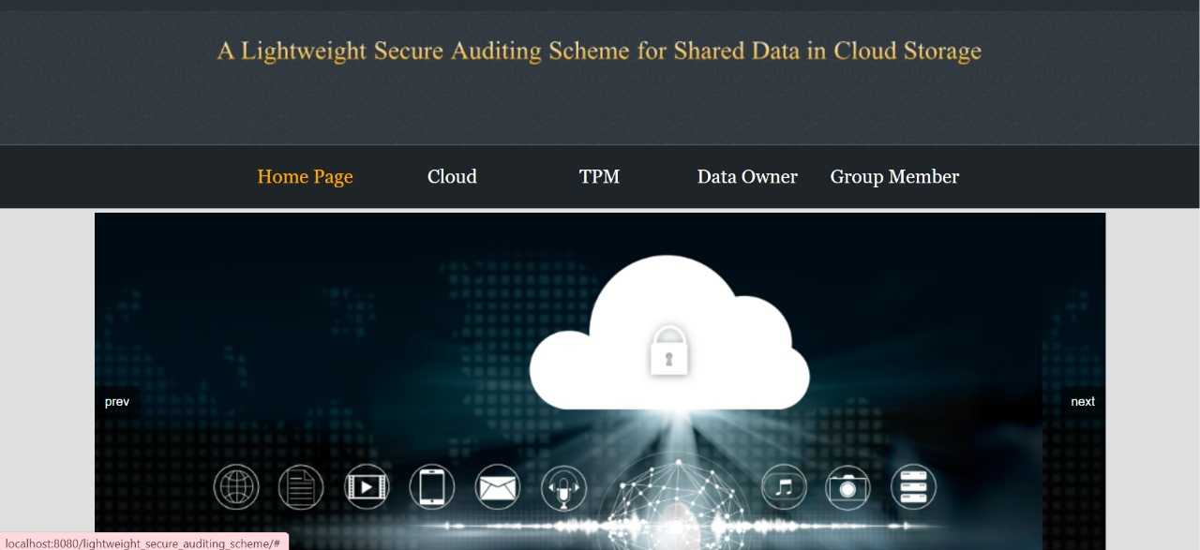
Output screen :8.1

8.2 cloud Login screen
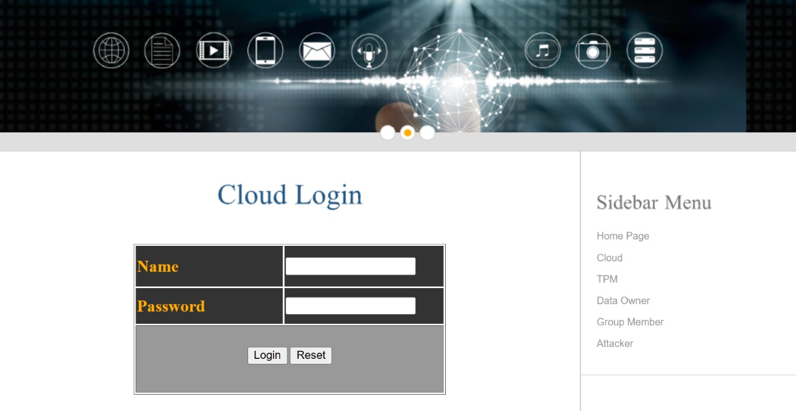
Output Screen: 8.2

8.3 Cloud login Screen after successful login
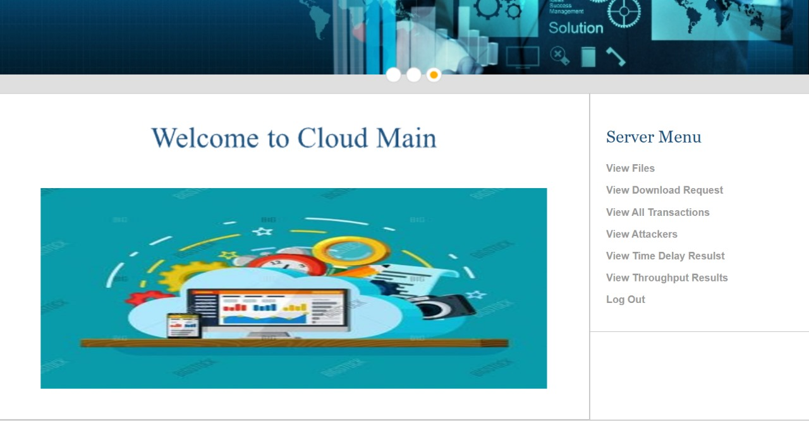
Output Screen: 8.3

8.4 TPM Login:
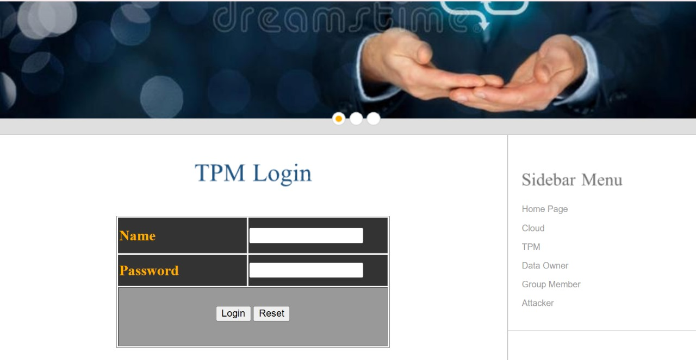

Output Screen: 8.4

8.5 TPM Login Successful
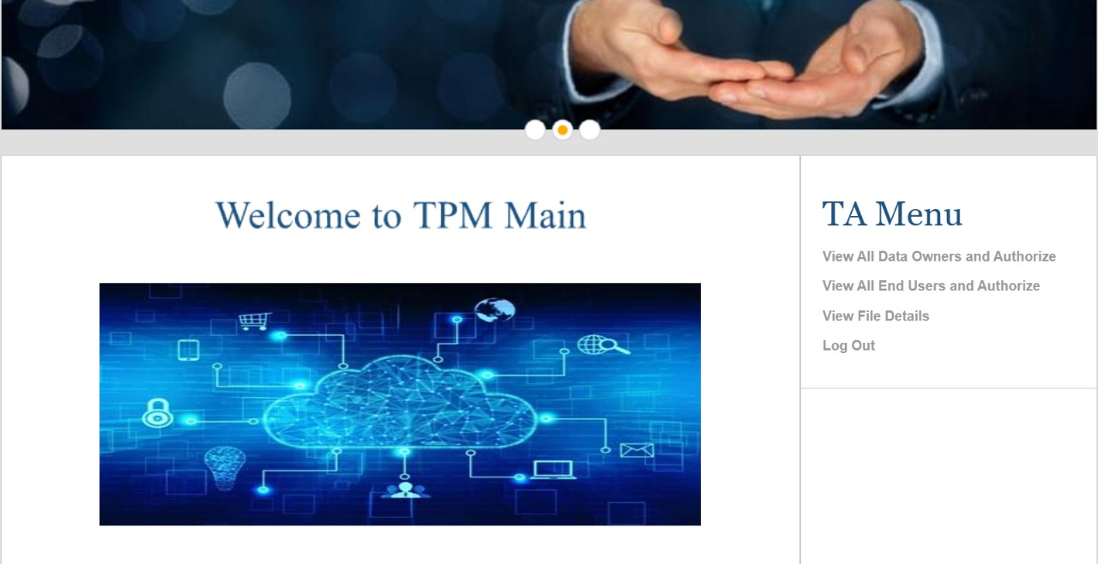
Output Screen: 8.5

8.6 Data Owner Login:
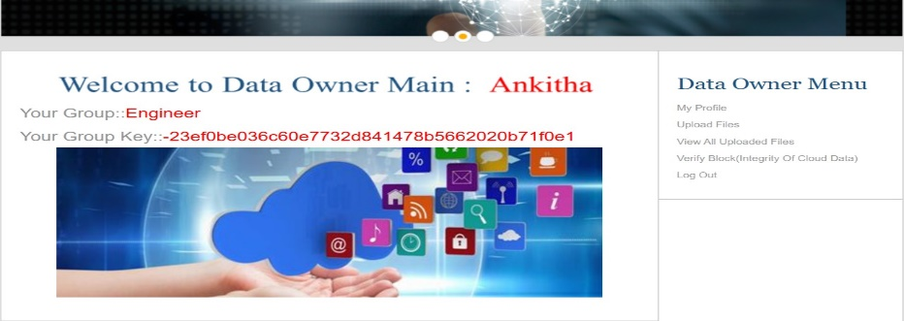
Output screen: 8.6
8.7 Group member Login
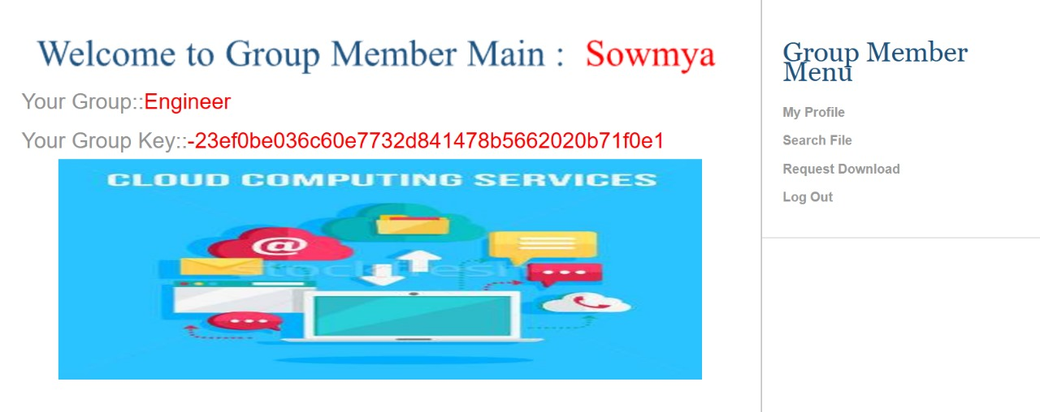
Output screen: 8.7

8.8 Verifying the Data owners
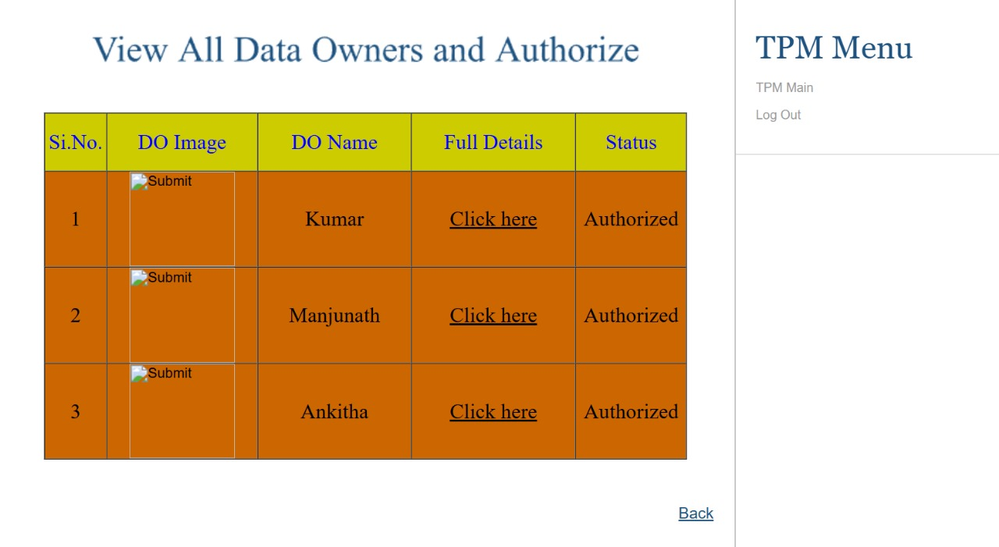
Output screen: 8.8

8.9 Request for File download
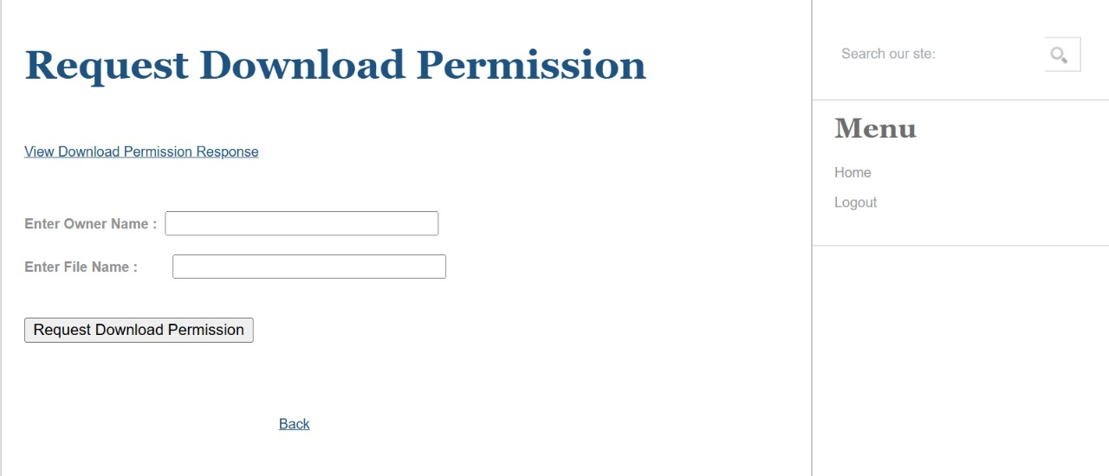
Output screen: 8.9

CHAPTER-9
CONCLUSIONS AND FUTURE ENHANCEMENT

9. CONCLUSIONS & FUTURE ENHANCEMENT
Conclusion:
In this paper, we proposed a provable shared data possession for a lightweight and security audit process in cloud storage. By introducing a Hash graph, the traceability of group membership is achieved, and the illegal behaviour of group members can be contained through Hash graph technology. By specifying multiple TPMs for calculation and management according to the TPM management strategy, each group member and each TPM are independent of one another, which ensures that the cloud data veriﬁcation process is secure and achieves a lightweight calculation of the TPM. Through a security analysis, the scheme in this paper can avoid replay attacks and replace attacks while protecting the identity privacy and data privacy of group members and ensuring secure storage of the shared data. Therefore, this scheme has important signiﬁcance and value for the secure storage of shared data.
Future Enhancement:
Future enhancements for a secure lightweight auditing scheme for shared data in cloud storage can focus on several key improvements. Integrating blockchain technology will provide tamper-proof audit logs, ensuring data integrity, transparency. Incorporating homomorphic encryption will allow audits to be conducted without exposing sensitive information. AI-based detection can identify unauthorized access and suspicious patterns, enhancing security. To safeguard against emerging threats, quantum-resistant cryptography should be integrated into the scheme. Supporting distributed multi-cloud auditing will enable seamless monitoring across different platforms. Enhancing fine-grained access control will ensure that audit logs are accessible only to authorized users based on their roles. Privacy-preserving techniques, such as Zero-Knowledge Proofs, will protect sensitive data during the auditing process. Implementing real-time monitoring help quickly detect and respond to security incidents. Automated compliance reporting can streamline regulatory processes, ensuring adherence to standards like GDPR. Using lightweight cryptographic schemes will reduce computational overhead, improving performance. Edge computing can decentralize the auditing process, speeding up data checks. Sharding will improve scalability, handling large datasets more efficiently. Audit log encryption will secure the audit trail, protecting it from unauthorized access.

CHAPTER-10
BIBILOGRAPHY

10. BIBLIOGRAPHY
[1] M. Armbrust et al., Above the clouds: A Berkeley view of cloud computing, Dept. Elect. Eng. Comput. Sci., Univ. California, Berkeley, Berkeley, CA, USA, Tech. Rep. UCB/EECS200928,2009.[Online].Available:https://www2.eecs.berkeley.edu/Pubs/TechRpts/2009/EECS-2009-28.pdf
[2] P. Mell and T. Grance, The National Institute of Standards and Technology (NIST) dentition of cloud computing, NIST, Washington, DC, USA, NIST Special Publication 800145,2011.[Online].Available:https://nvlpubs.nist.gov/nistpubs/Legacy/SP/nistspecialpublication800-145.pdf
[3] K. Julisch and M. Hall, Security and control in the cloud, Inf. Secur. J. Global Perspective, vol. 19, no. 6, pp. 299309, 2010.
[4] D. G. Feng, M. Zhang, Y. Zhang, and Z. Xu, Study on cloud computing security, J. Softw., vol. 22, no. 1, pp. 7183, 2011.
[5] G. Ateniese et al., Provable data possession at untrusted stores, in Proc. 14th ACM Conf. Comput. Commun. Secure. (CCS), 2007, pp. 598609.
[6] A. Juels and B. S. Kaliski, Pors: Proofs of retrievability for large les, in Proc. 14th ACM Conf. Comput. Commun. Secure. (CCS), 2007, pp. 584597.
[7] G. Ateniese, R. Di Pietro, L. V. Mancini, and G. Tsudik, Scalable and efficiently provable data possession, in Proc. 4th Int. Conf. Secur. Privacy Commun. Netw. (ICST), Istanbul, Turkey, 2008, pp. 2225.
[8] H. Shacham and B. Waters, Compact proofs of retrievability, in Proc. Int. Conf. Theory Appl. Cryptol. Inf. Secur. Berlin, Germany: Springer, 2008, pp. 90107.
[9] G. Yang, J. Yu, W. Shen, Q. Su, Z. Fu, and R. Hao, Enabling public auditing for shared data in cloud storage supporting identity privacy and traceability, J. Syst. Softw., vol. 113, pp. 130139, Mar. 2016. doi: 10.1016/j.jss.2015.11.044.
[10] T. Jiang, X. Chen, and J. Ma, Publicintegrity auditing for shared dynamic cloud data with group user revocation, IEEE Trans. Comput., vol. 65, no. 8, pp. 23632373, Aug. 2016. doi: 10.1109/TC.2015.2389955.

CHAPTER-11

YUKTI CERTIFICATE

